Adding subtitles to you tube in a range of languages.

 1. Click here on settings

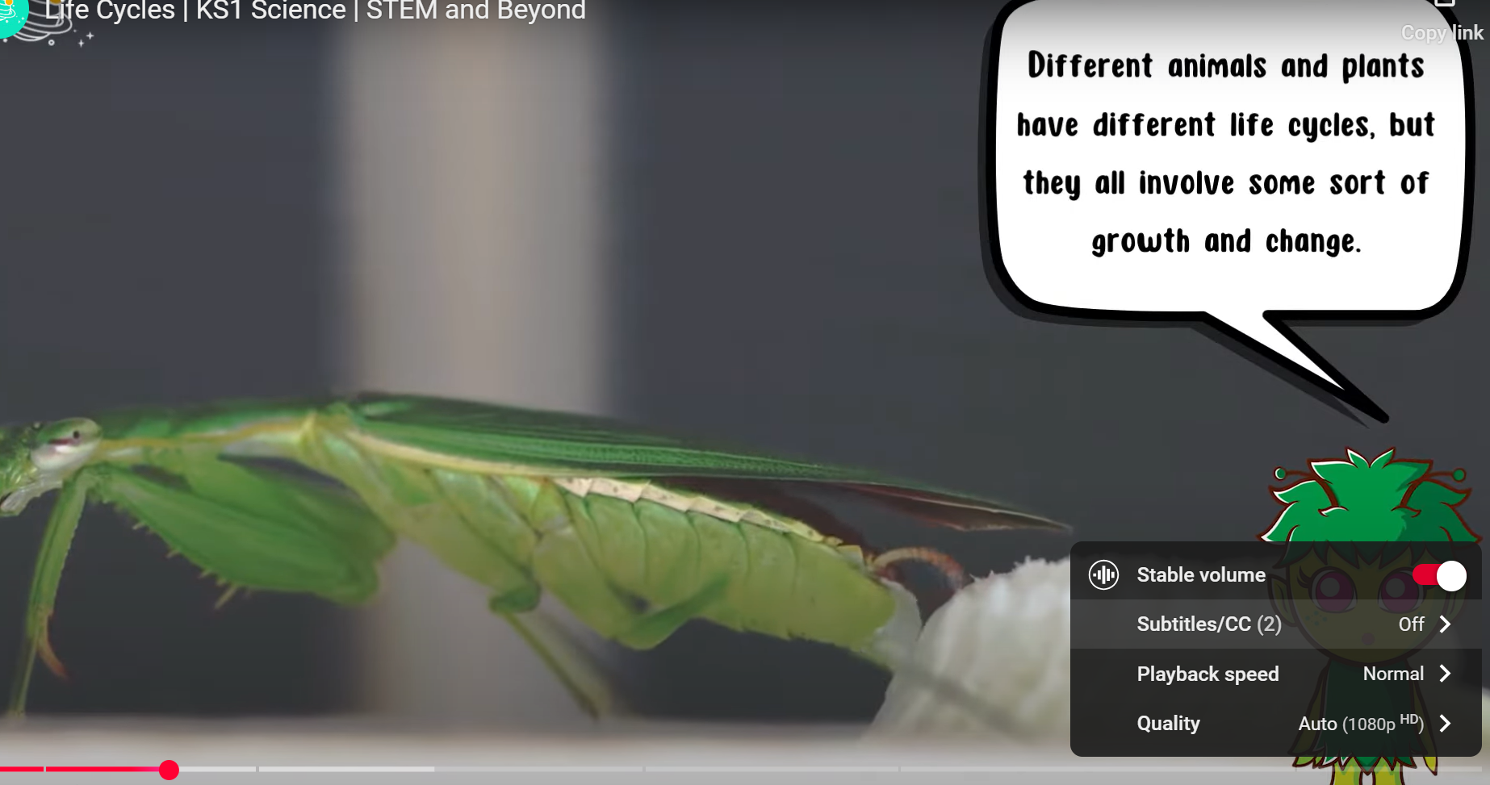 2. Click on subtitles

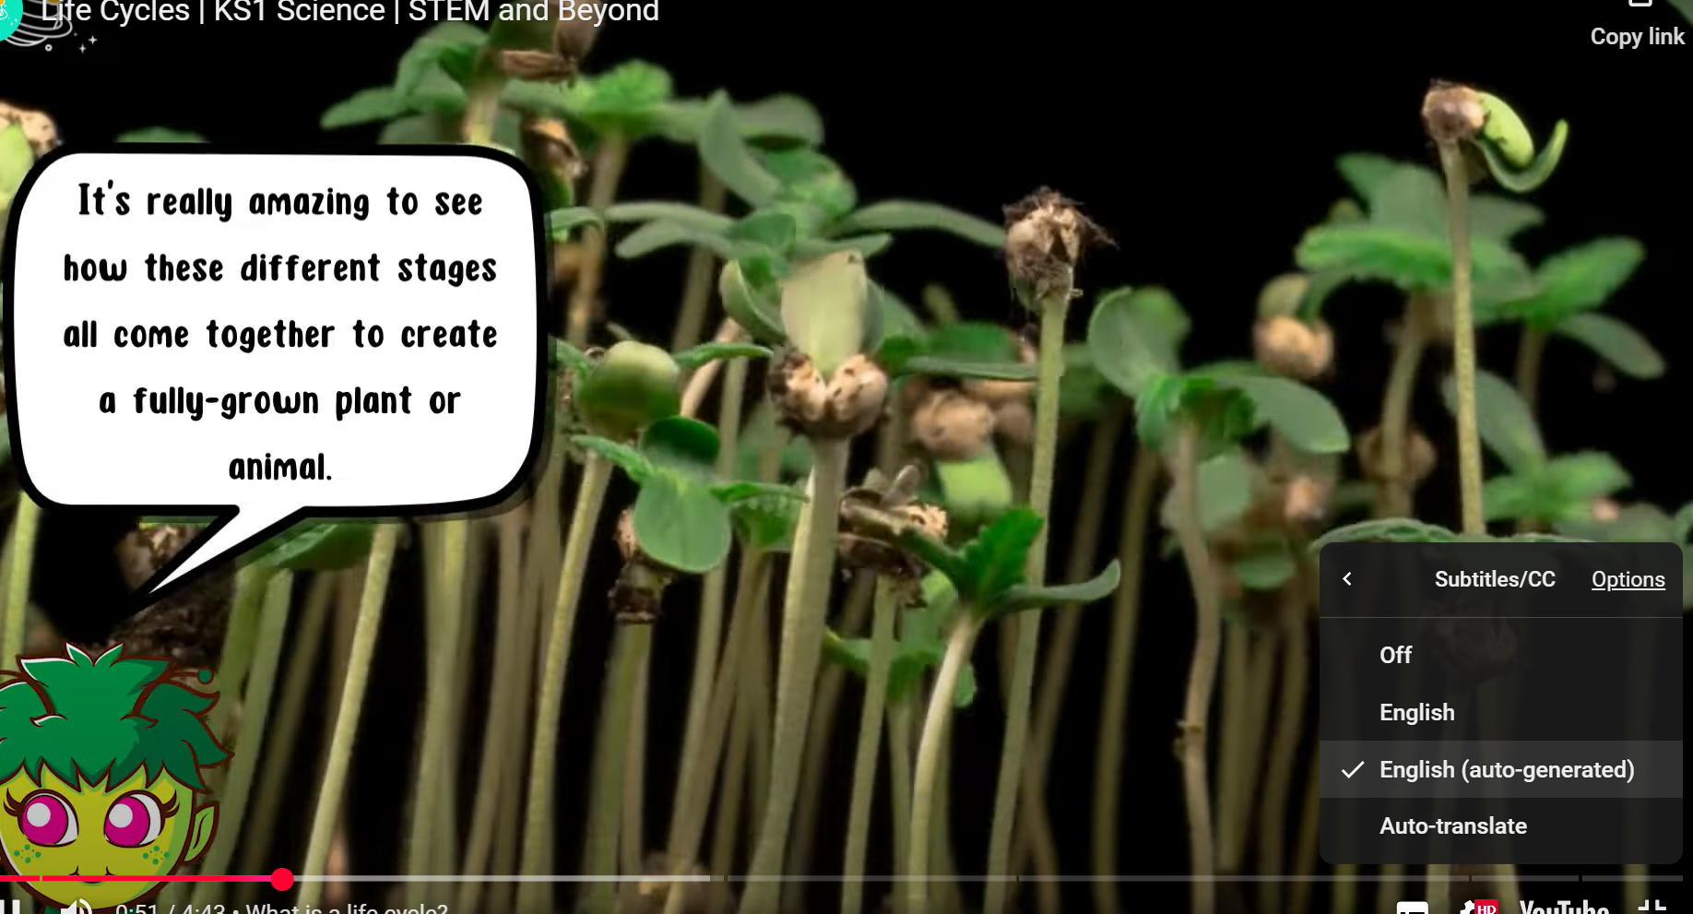 3. Click on English (Auto-generate)

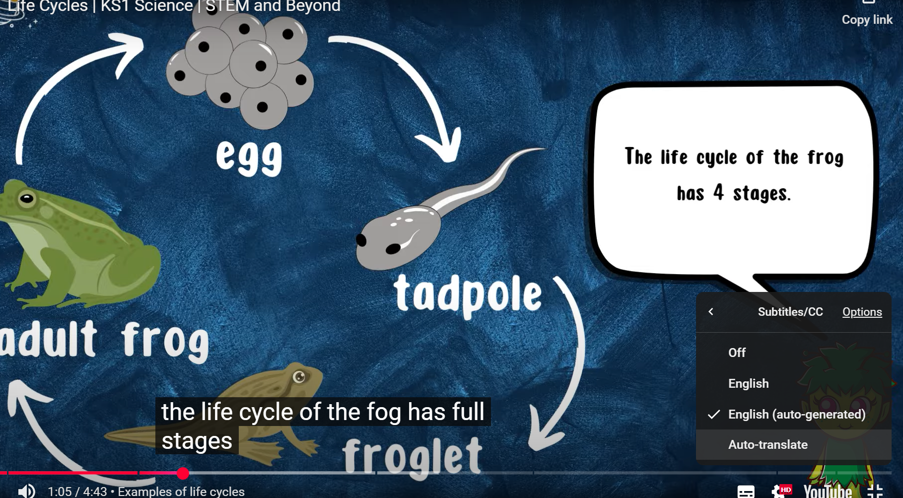 4. Click on Auto Translate

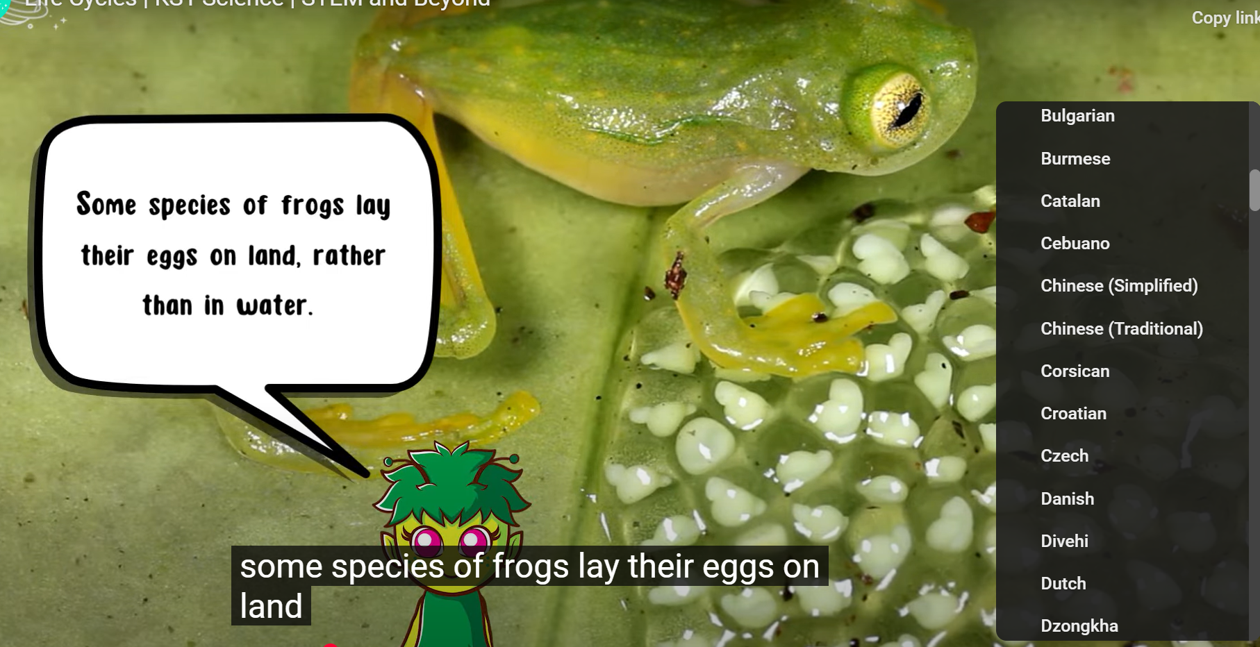 5. Select the language you would like.

 6. Subtitles are now in your chosen language.

